**Group 15 report for F21SF / F20SF Assignment 2**

1. Group 15 Members:

(i) Lynsey Kirk

(ii) Rachana Patel

(iii) Robert Stone

2. Status Report:

* This application meets the specification fully
* User input errors handled by Group 15 application:-

|  |  |
| --- | --- |
| Competitor number entered in GUIOne (Competitor Score Tab) and GUIThree (ID Search Tab) which does not correspond to any in the list | ‘Competitor not found’ message displayed. |
| Non-numeric data entered in GUIOne (Competitor Score Tab) and GUIThree (ID Search Tab) for the competitor number | Handled and programme does not crash. |
| Competitor number not entered and submit button clicked in GUIOne (Competitor Score Tab) | ‘no competitor entered’ message displayed |
| Competitor number not entered and OK button clicked in GUIThree (ID Search Tab) | ‘no text entered’ message displayed |

3a. Use Case Diagrams and description:

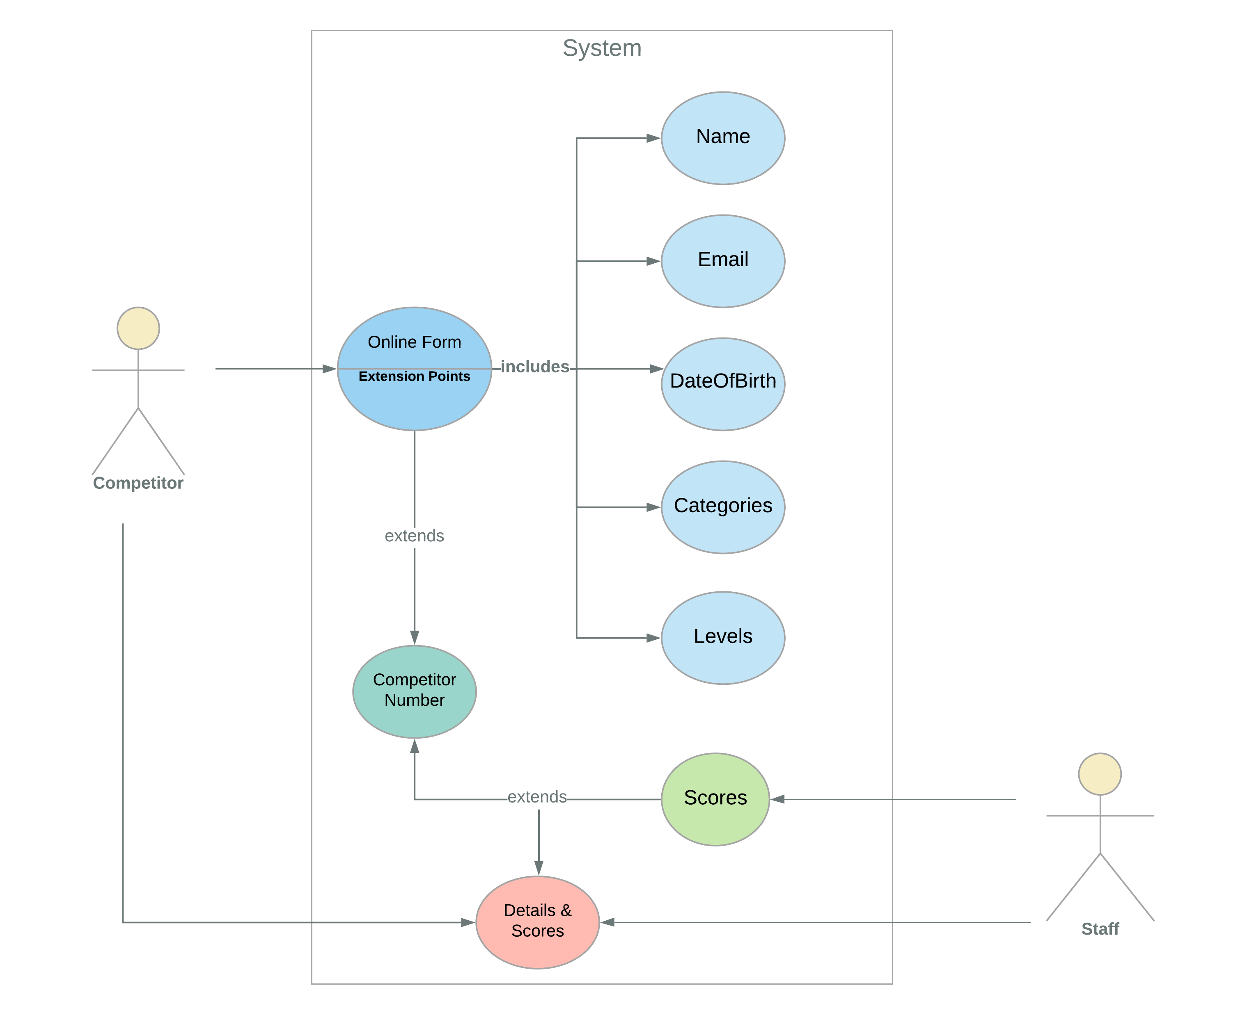

Figure1: Basic Flow for Competition Details Use Case

Brief Description

Competition Details Use case captures the process of registering and associating the scores with competitors via competitor number, which is the unique identifier of the competitors registering for a particular competition. This use case begins with a competitor registering for a competition by filling up the online registration form and ends with both staff and competitor able to access the details and scores.

Actors

Competitors

Staff

Basic Flow

The basic flow of the Competition Details use case is shown in figure 1. A competitor enters the required details including name, email, date-of-birth, categories and levels in an online registration form. Once all the necessary information is entered, the competitor is accepted and receives a competitor number for the registered category and level. Once the scores are given, a member of the staff assigns the appropriate scores to the competitor number. Both competitor and staff can access the scores and details of the competitor via competitor number.

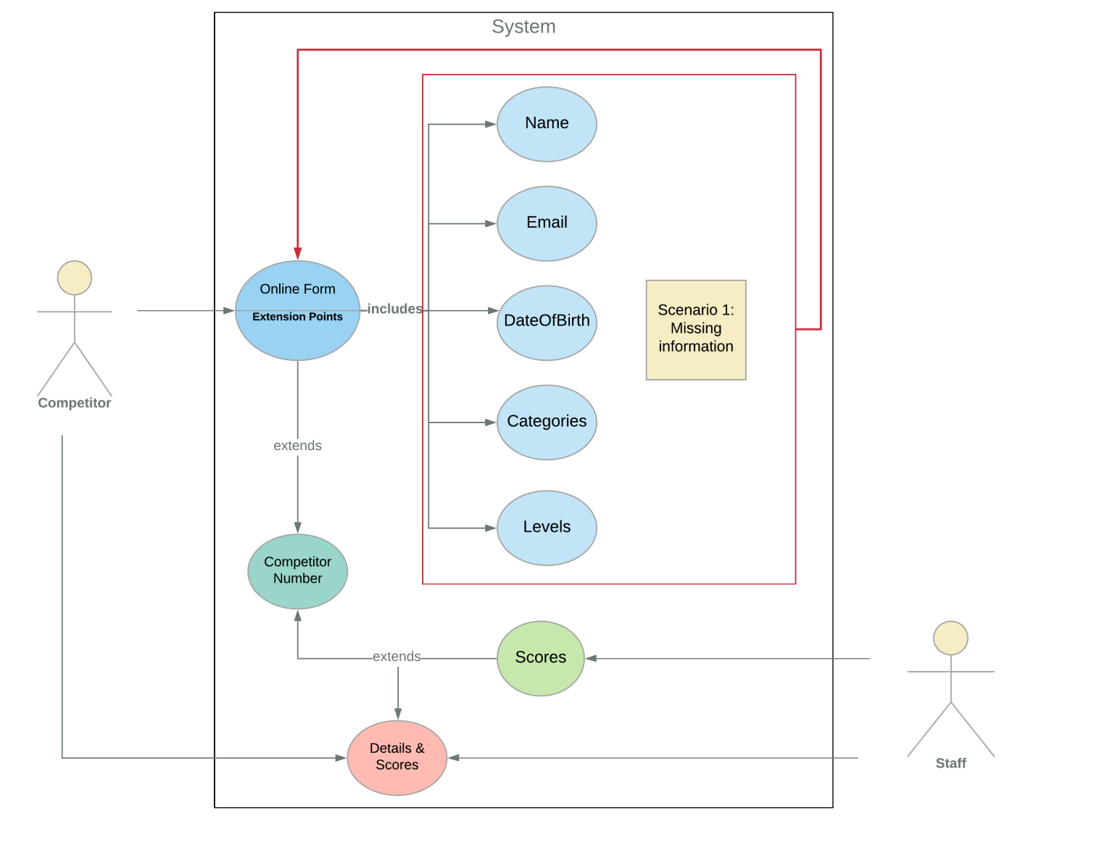

Figure 2: An Alternate Flow scenario 1 for Competition Details Use Case

Alternate Flow

Scenario 1:

As shown in figure 2, if the competitor has missed out any of the required information such as name, email, date of birth, categories or levels in the online registration form, they are redirected back to the beginning of the online submission form to enter all the required information.

Scenario 2:

As shown in figure 3, if a competitor already exists with the same email address and the same category, the registration is refused, and the use case ends.

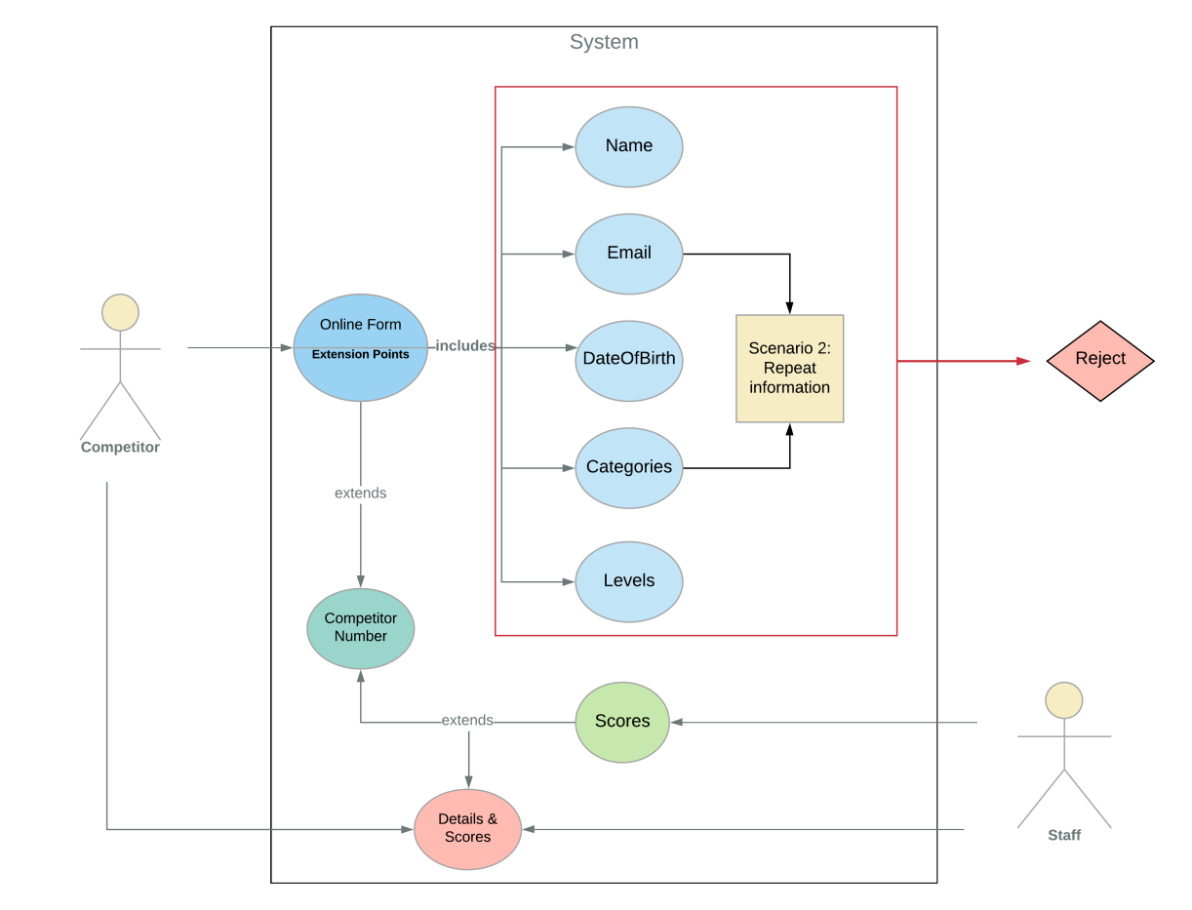

Figure 2: An Alternate Flow scenario 2 for Competition Details Use Case

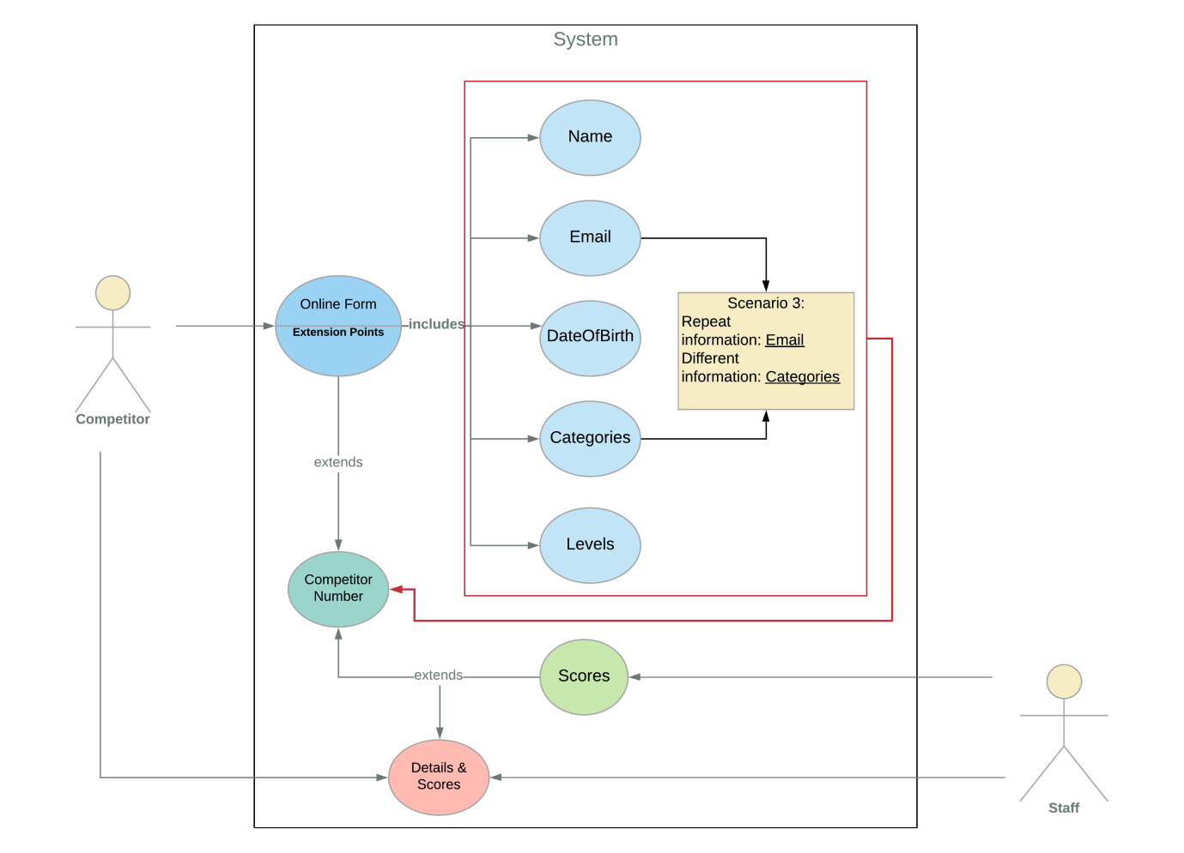

Figure 4: An Alternate Flow scenario 3 for Competition Details Use Case

Scenario 3:

As shown in figure 4, if a competitor already exists with the same email address and for a different category, their registration is accepted, and they are allocated a different competitor number for this category.

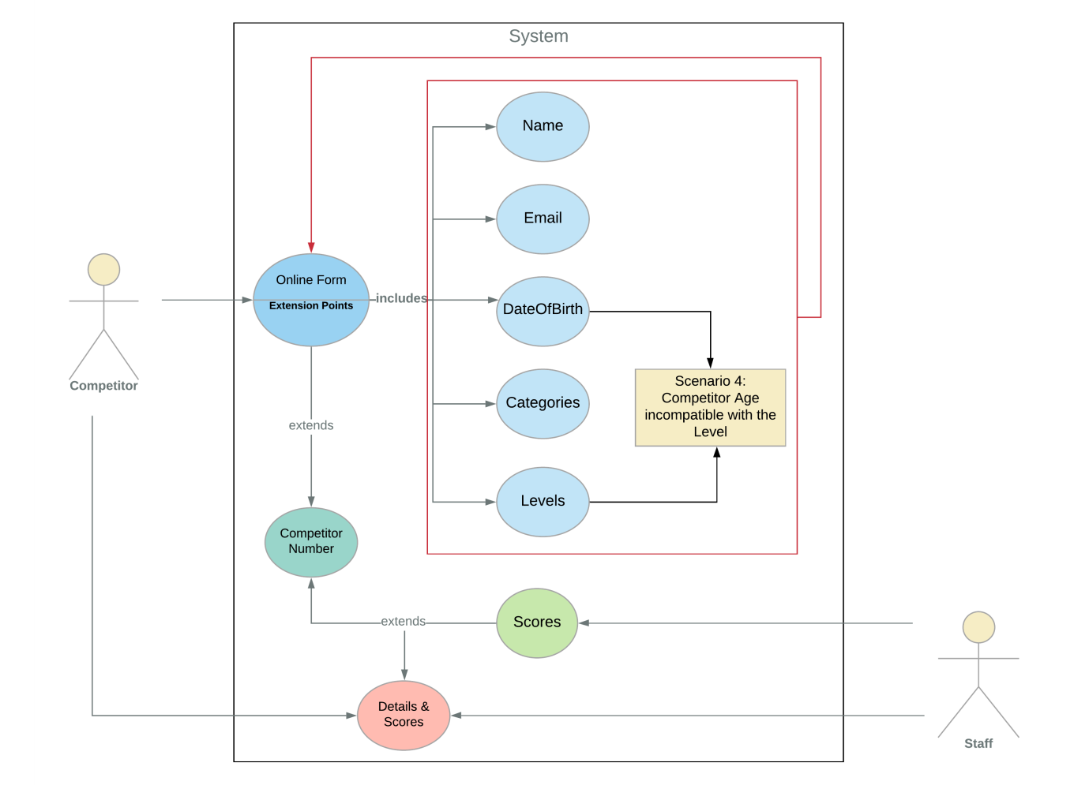

Figure 5: An Alternate Flow scenario 4 for Competition Details Use Case

Scenario 4:

As shown in figure 5, if a competitor’s age is incompatible with the level, the competitor is offered the opportunity to re-submit the form for a different level and is re-directed to the beginning of the use case.

Once the required pre-conditions of the necessary details such as all relevant information entered, no dual registration of the same competitor for the same category of competition and appropriate age compatibility are met, the competitors are assigned a competitor number. When the scores are given, a member of the staff assigns the appropriate scores to the competitor number. Both competitor and staff can access and view the scores and details of the competitor via competitor number.

Activity Diagrams:

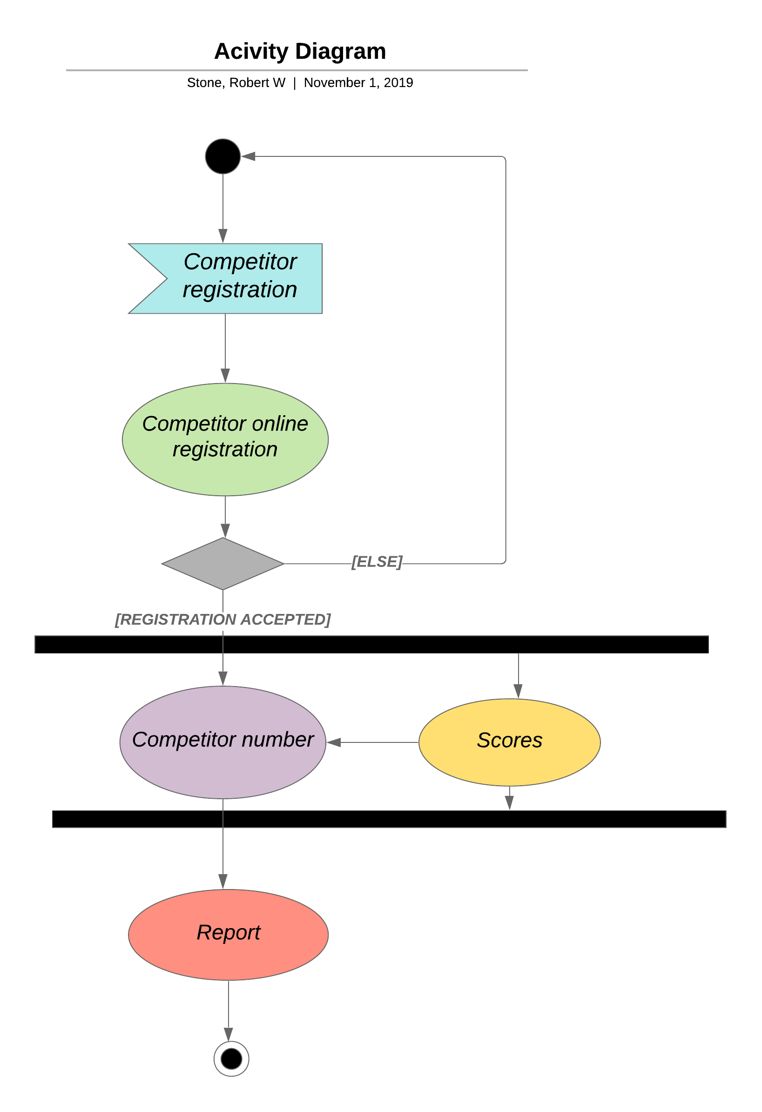

Figure 6: Activity Diagram (Please refer to figure 7 for the expanded activity diagram of competitor registration)

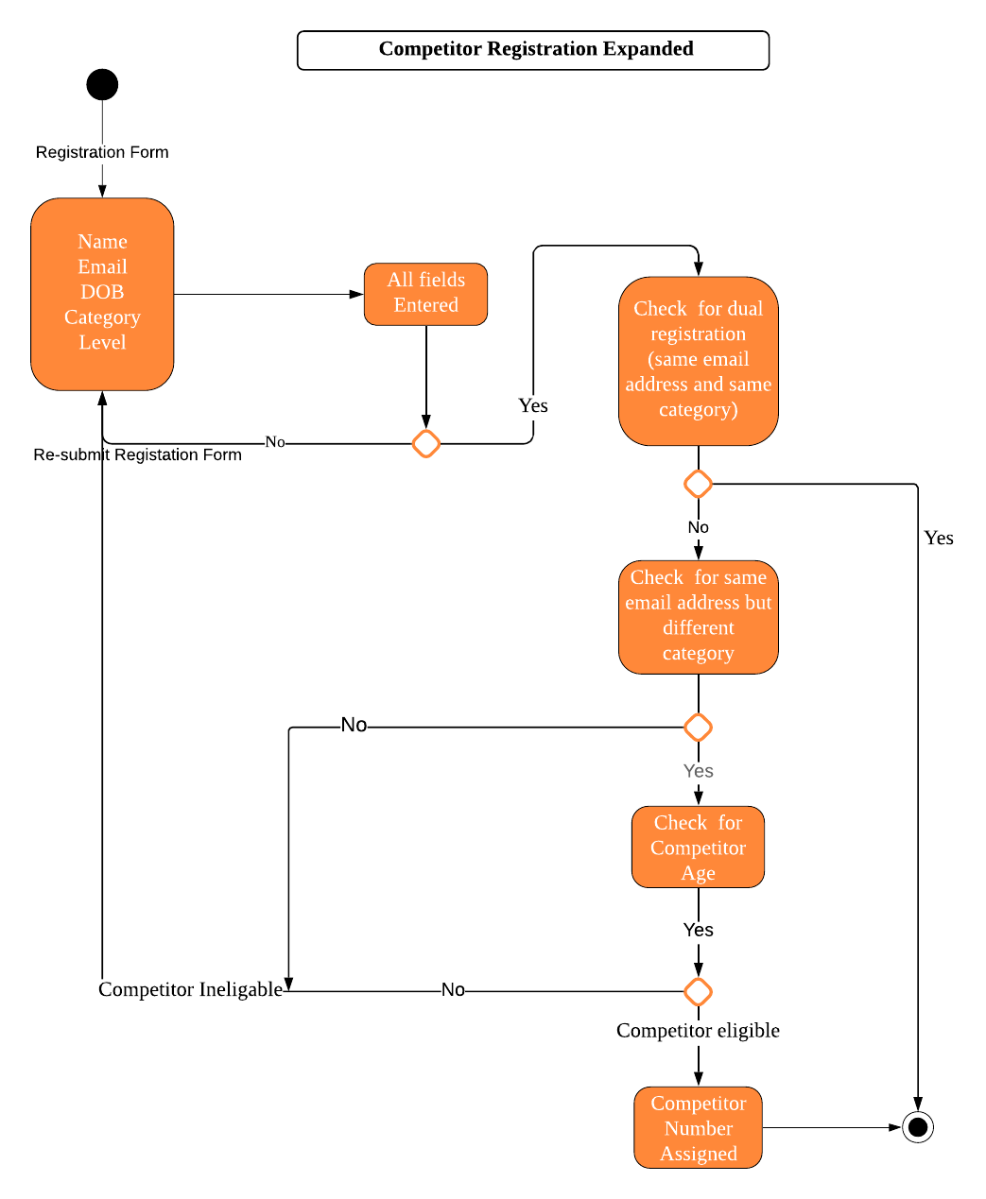

Figure 7: Expanded Activity Diagram for Competitor Registration